
you gave me peace

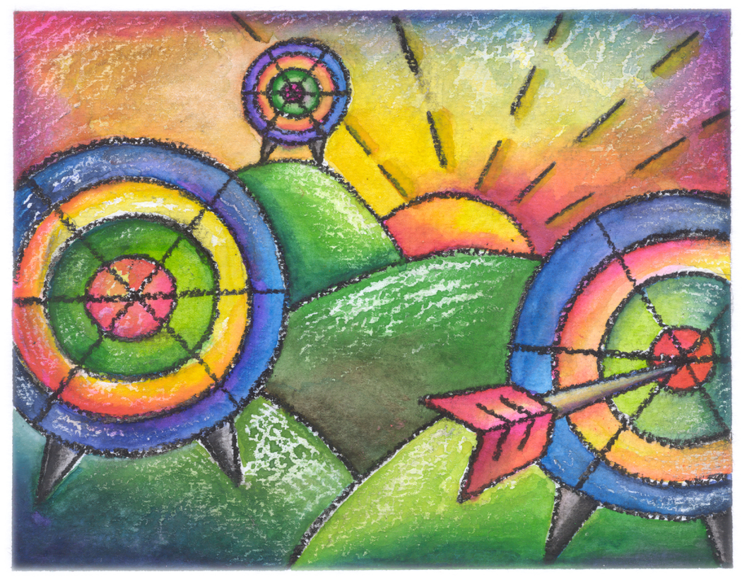
by achilles

you gave me peace, briseis
you held me in the dark
you are a ray of light (alright, the arrow hit the mark)

you have a way, you have (today)
you gave me this, at least
you didn’t ask for my dark kiss,
you gave, you gave me peace

martino, j. (4-27.1-2007). book 52: dark matter. © 2008 by wellnesseducation.us. inspired by a line by “achilles,” from the movie “troy.” picture from an unknown website (needs citation).

