february’s thoems

february’s thoems are in the process of being placed on the “poem of the day” engine at wellnesseducation.us. initially, the february theme appears to be “Spirit” as i review thoughts from the first few days of the books “Baklavahhh, miss u, and Ahhhhhs.” it appears as if “wizard of Oz” theology permeates the month of february. as All-ways, there are several hidden meanings in just about every thoem, so be keenly aware of spelling and punctuation. please read the 10-minute book entitled “Spiritual Scripting” in order to decode any-thing that you (ever) read.
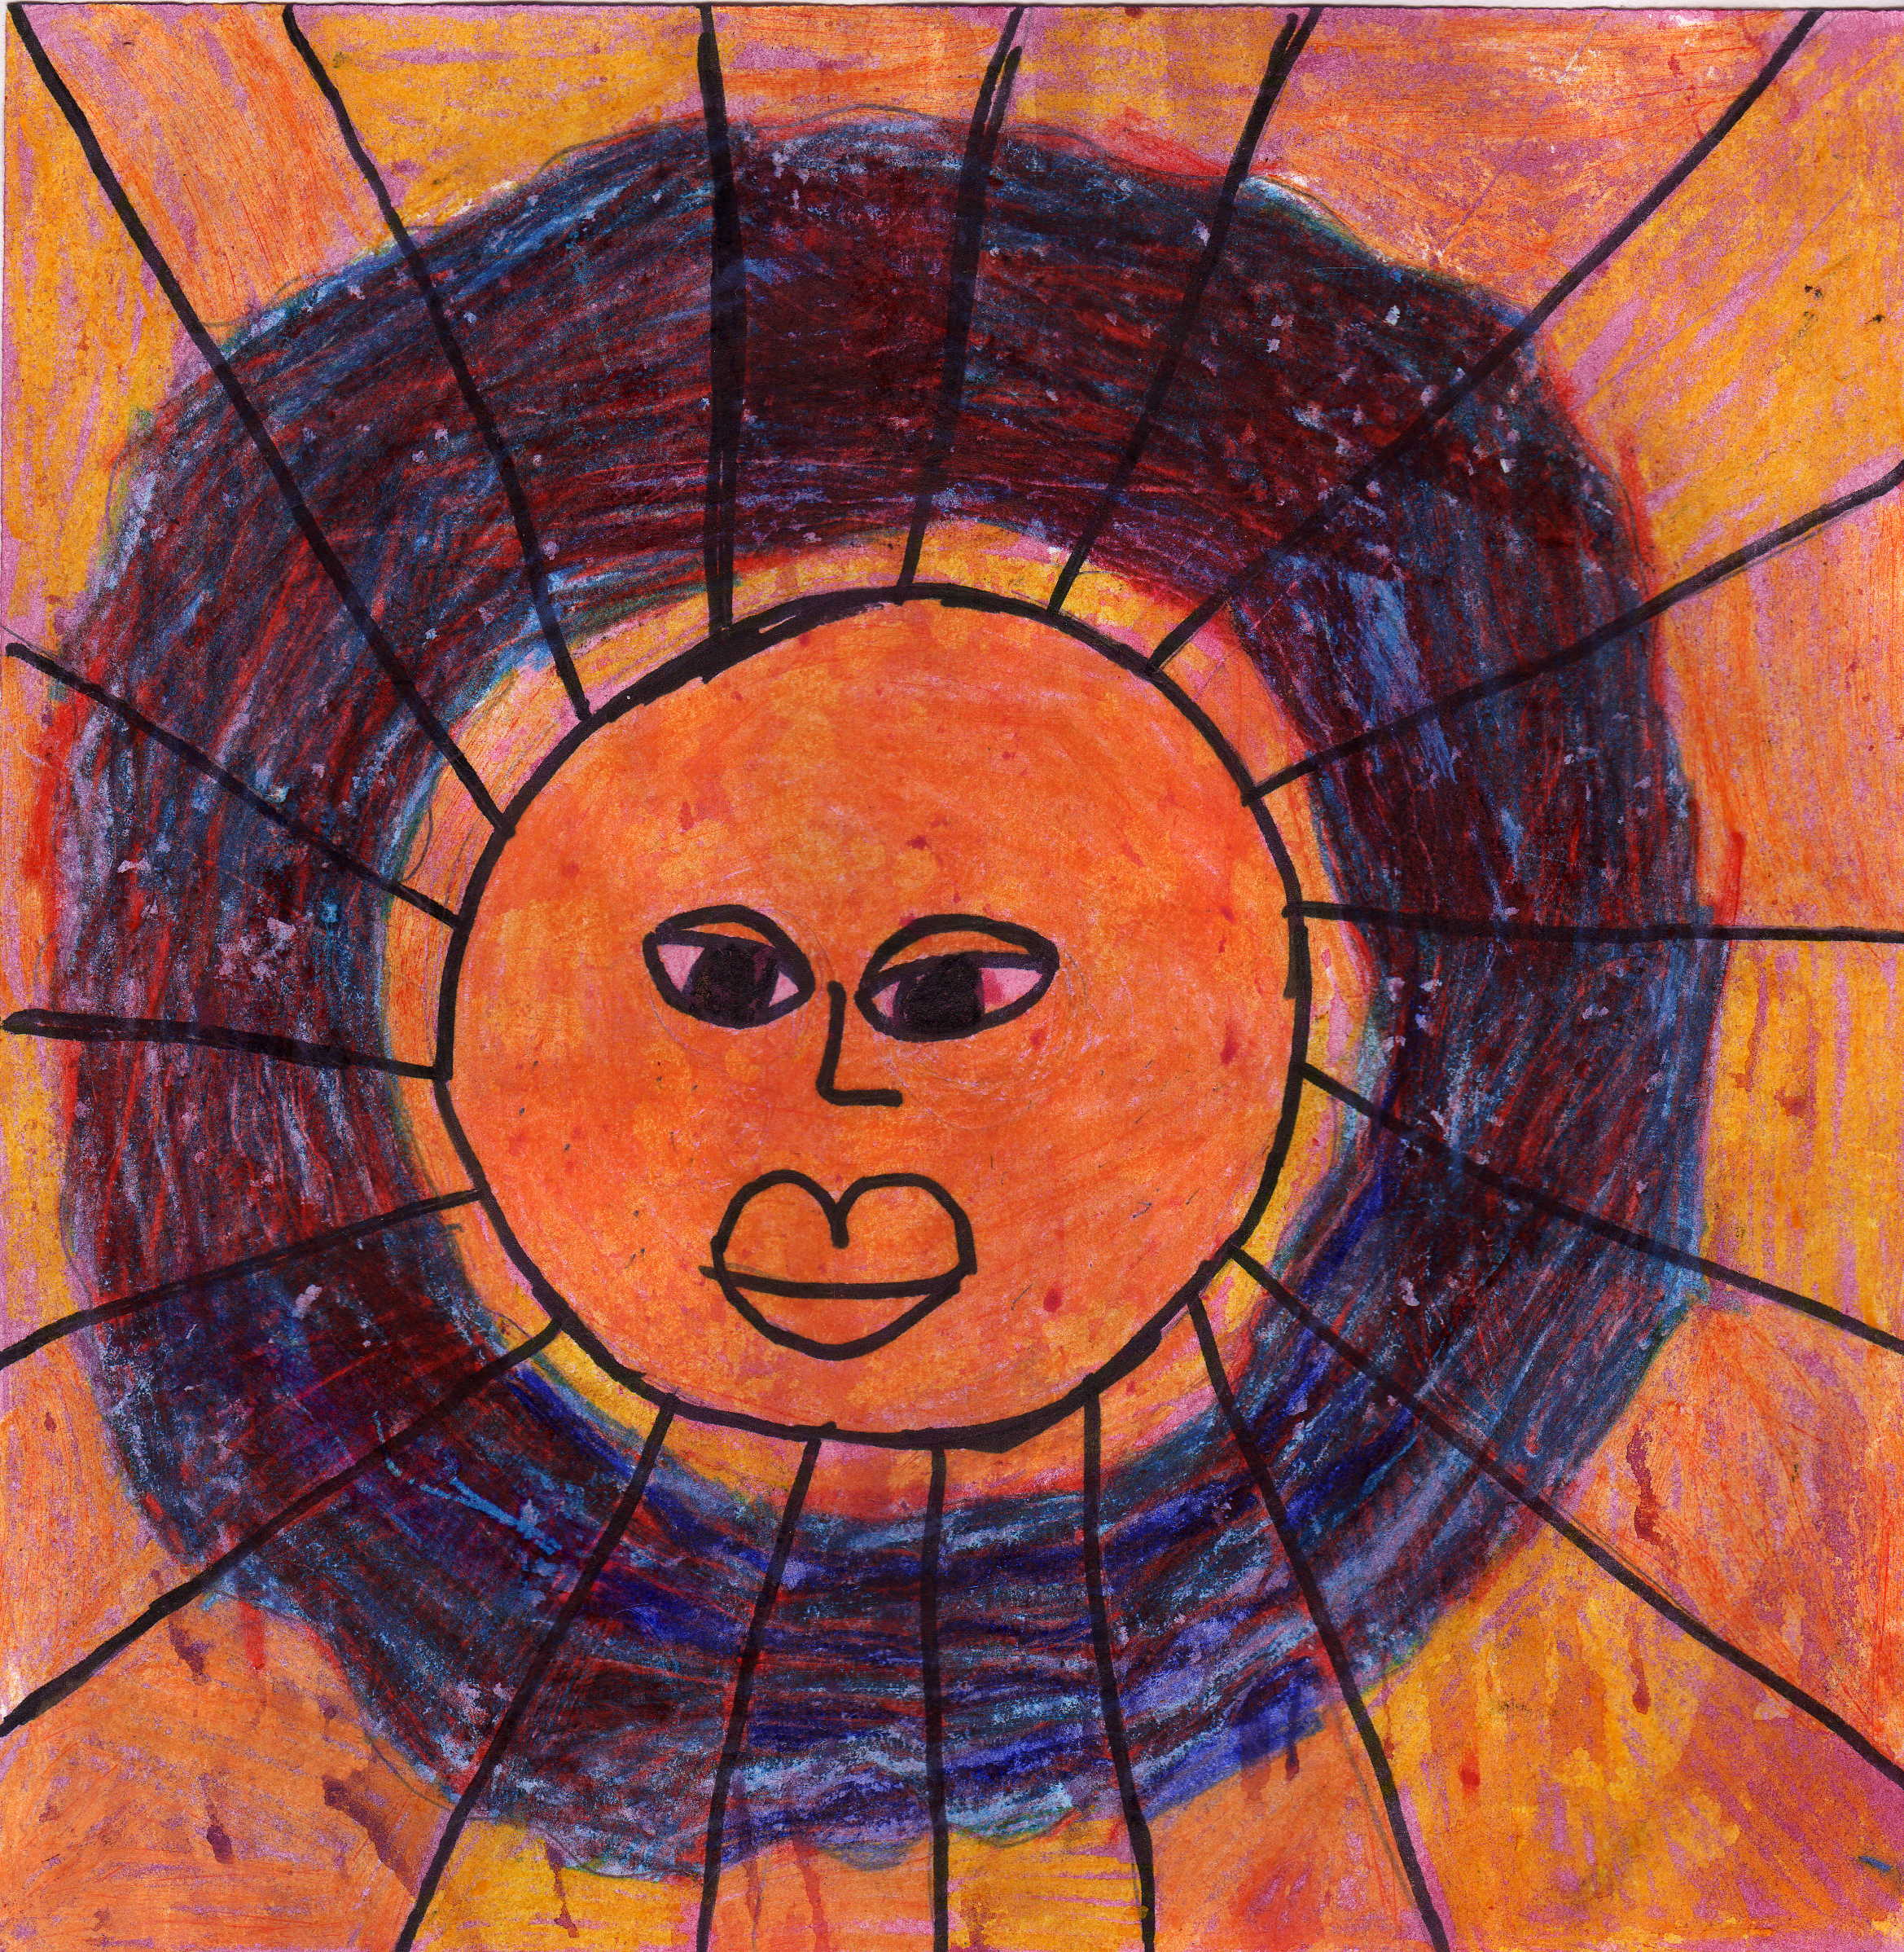
these thoems were all written in the month of february (2001 – 2010). they are excerpted from the following books (so far):

- book 16: Baklavahhh (february, 2003)
- book 27: miss u (february, 2004)
- book 39: Ahhhhhs (february, 2005)
- book 46: msd (february, 2006)
- book 50: i mind be-Cause I, Mind (jan-march, 2007)
- book 58: side effects (february, 2008)
- book 66: you are here for a reason (feb-april, 2009)
- book 68: wonder-Full (feb-TBA, 2010

it’s a work in process, and you are part of that process. contact me if you have an idea, if you notice a typo, or if you want to say “hi!”

click on any thoem, any day, and it should open for you as a microsoft word document.
the way to determine the exact day that a thoem was written, check the reference citation at the bottom of the page. the reference will looks like this:
author’s last name, first name [or initial]
book title. “book 25” means “25th^{th} book of thoetry.” there are 50-100 thoems/ideas per thoetry book.

martino, joal (12-2.5-2004). book 25: smoke & mirrors. © 2007 by wellnesseducation.us
standard “month-day-year’ format is used, except when a “decimal point” is used to describe the day/date of thoem.

example: “2.5” (above) means “second day of the month, fifth thoem written on that day.”
copyright. see our liberal copyright rules at wellnesseducation.us’ welcome page.

disclaimer:

none of these thoems are meant to represent the thoughts/ideals of the wellness education institute. every poem can be considered “draft.” in fact, any poem could be “here today, gone tonight.” most are written using a passive writing technique, in which the thoet simply allows words and ideas to flow through his fingertips. In-Joy them while you can : )
format:
most of the joal-poems seem to follow a similar format, as shown below.

the poem “title” is usually bolded, and underlined

a “by” line, if shown, is usually in size 10 font (the “by” line usually reveals some sort of clue, or is a play on words)

the written poem (in size twelve text)
is privy to what’s coming next

(a little bit perplexed)
_____________________________ italicized font is the standard font for poems. a line is often used to separate the “poem” from the “take” section, which is usually in standard font.

- some poems have a “take.”

- “the take” is delivered in bullet format, with commentary that relates to the poem.

- “takes” and poems are usually written in Spiritual Script, unless otherwise noted.

- Spiritual Scripting is joal martino’s evolving writing style… that allows you to translate anything you ever read or hear. the technique is expressed as follows:

  - Capitalize words that show a definite tendency toward Higher Power, Unity, or Spirit.
  - lower-case any word that shows a movement toward ego, matter, or separation.
  - re-Configure words with hyphenation, miss-spelling,
  - use coloration (blue shows a movement toward Spirit, while red shows a tendency toward ego, fear, matter, or separation).
  - (use parentheses, to capture thoughts with-In thoughts)
  - symbology is in-fused, by utilizing circles, lines, arrows, etc. circles re-Present Wholeness, arrows re-present direction, infinity signs (or connected circles) re-present the infinite dance of duality.
  - see the “10-minute book” entitled “Spiritual Scripting” (on sale in our bookstore) for a deeper description of Spiritual Scripting. Once you understand “Spiritual Scripting, everything else works.
- pictures/graphics may be inserted, throughout the poem. 95% of the graphics come from microsoft clipart, a small percentage comes from m-Art-i-neau art, and a very small percentage is unaccounted for. it is not my intention to use other people’s pictures or graphics. if you find that i’ve used someone else’s picture or graphic and not included the citation, please let me know and help me get permission to continue using it.

since this website is a very small, part-time operation as of 2007-08, the e-books may take a little time to publish in our store.

thank you for your patience. -joal

martino, j. (2-3.1-2008). this document is not in a book. the picture (above) is entitled “son of a sun” by abby williams. © 2007 by wellnesseducation.us, it is available in the wellnesseducation.us store.
most of the poems have references. the reference shows: last name, first name. (date of the poem). book number: book title. copyright date. comments, citations, inspirations. the books will be published on wellnesseducation.us (in the wellnesseducation.us store).

